Checklist for a Proficient Paragraph
- Clear topic sentence (relates to prompt)
Topic Sentence
- States what paragraph will be about
- Grabs reader’s attention
- Doesn’t give specific information
- Background Information
- Main Point # 1
- Explain/Prove it
Main Points
- At least 3 in a paragraph
- Breaks topic up into smaller pieces
- All relate back to topic sentence
- Explain/Prove it
- Main Point # 2
- Explain/Prove it
Explain/Prove Its
- Explains main point
- Give examples of main point
- Add SPECIFIC details about MP
- Explain/Prove it
- Main Point # 3
4  (Advanced) | 3  (Proficient) | 2  (Partially Proficient) | 1  (Unsatisfactory)
A strong, clearly written paragraph which:  - Includes a unique topic sentence  - Includes relevant, interesting background information  - Contains at least 3 strong main points that all relate to the prompt and support the topic sentence  - Contains strong explanations/prove its for each main point that connect both to main point and back to topic sentence  - Includes unique concluding statement giving final thoughts | A clearly written paragraph which:  - Includes a clear topic sentence (ex. O/P; compound sentence; restate prompt)  - Includes relevant background information  - Contains at least 3 main points that all relate to the prompt and connect to the topic sentence  - Contains at least two explanations/prove its for each main point that connect to main point  - Includes clear concluding sentence | A paragraph which:  - Attempts a topic sentence  - Attempts background information  - Contains 2 main points/details that relate to the topic/prompt and connect to the topic sentence  - Missing or irrelevant explanations/prove its for SOME main points  - Attempts a concluding sentence | A paragraph which:  - Does not include a topic sentence  - Does not include background information  - Contains 0-1 main points that relate to the topic/prompt and connect to the topic sentence  - Contains FEW/NO relevant explanations/ prove its  - Does not include a concluding sentence
- Explain/Prove it
Concluding Sentence
- Connects back to topic sentence
- Doesn’t give new information
- Makes paragraph feel finished
- Explain/Prove it
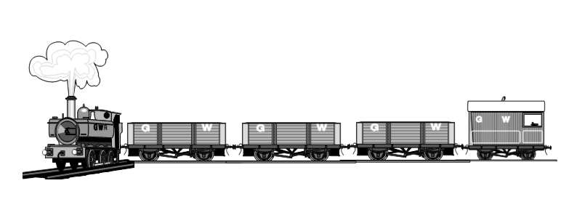
- Clear concluding sentence which connects back to topic sentence

