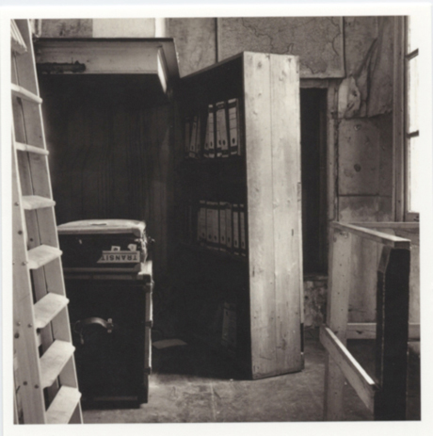
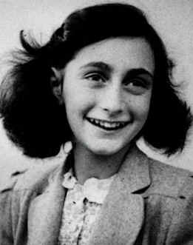
World War II begins. No one one is safe. Anne Frank is a girl that lives in Amsterdam, Holland, in the Netherlands. Anne lives in her home with Margot, her sister, her dad Otto Frank, and her mom. While living at home, she meets Harry and they become friends. They walk to school with each other, Harry goes over to hang out with Anne, and she goes over there also. They become really good friends, but then the Franks make unexpected plans to escape their home and live at a work office to hide. There was a door to the entrance of the Secret Annexe, which was what Anne would call it. But they are not the only ones hiding. Later, the Van Daans arive. Now, there are 7 people living in the temporary home. Still, there are more coming. Some of them are Elli, Koophuis, Miep, and the Van Daans are Peter, and Mr. and Mrs. Van Daan (never mentions their name). One thing the do to make themseleves a little more hidden is make a bookshelf on the door. Although it may seem that it was easy with the door, but Anne Frank doesn’t like everybody living in the house. She and Mrs. Van Daan aren’t the greatest friends in the beginning. Then, as they start to live with each other, they begin to become better friends. Other than this, people that they are living with are getting sick, one even gets the flu. Life was very rough for them, as Anne says. One exotic thing that happens during this time is that a plane crashed into a school near them. But worse, D-day begins. This is when it becomes really bad. Read the rest of the book, Diary of Anne Frank, by Anne Frank, to find out what happens next.
Anne Frank in 1944
The Entrance to the Secret Annexe

