Essay Body Paragraphs
Purpose:
The body paragraphs in your essay support the main idea in your thesis statement by breaking it down into smaller ideas or subtopics.
All ideas in your paragraphs should relate back to the thesis statement.
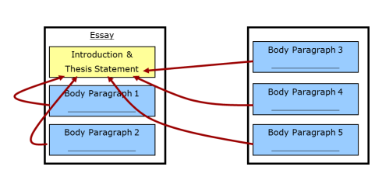

ORGANIZATION: As with the summary paragraphs you wrote earlier this year, your body paragraphs should have several key pieces:

- Topic Sentence: States main idea of paragraph and connects to your thesis statement
- Main Point # 1
- Explanation/Prove It
- Explanation/Prove It
- Transitions Throughout Paragraph
- Repeat as Needed
ELABORATION: Elaboration means to tell the reader more about an idea using
- Answers to a reader’s predicted questions
- Specific words
- Onion-like layering of detail
- Specific strategies, such as reasons, examples, definitions, descriptions, and anecdotes

UNITY: Good paragraphs have unity. That means that each sentence in the paragraph is related to the topic sentence. Unified paragraphs also discuss only one main idea.

Essay Body Paragraphs
Purpose:
The body paragraphs in your essay support the main idea in your thesis statement by breaking it down into smaller ideas or subtopics.
All ideas in your paragraphs should relate back to the thesis statement.

ORGANIZATION: As with the summary paragraphs you wrote earlier this year, your body paragraphs should have several key pieces:

- Topic Sentence: States main idea of paragraph and connects to your thesis statement
- Main Point # 1
- Explanation/Prove It
- Explanation/Prove It
- Transitions Throughout Paragraph
- Repeat as Needed
ELABORATION: Elaboration means to tell the reader more about an idea using
- Answers to a reader’s predicted questions
- Specific words
- Onion-like layering of detail
- Specific strategies, such as reasons, examples, definitions, descriptions, and anecdotes

UNITY: Good paragraphs have unity. That means that each sentence in the paragraph is related to the topic sentence. Unified paragraphs also discuss only one main idea.

